Name – G.Akshath Roll.No - 2420030512
Experiment 2
Case Study: Campus Event Management and Registration System
The Campus Event Management and Registration System (CEMRS) is a web-based application designed to simplify the planning, management, and participation of college events.
In many colleges, event registration, participant management, scheduling, attendance, notifications, and feedback are handled through separate forms, spreadsheets, messaging applications, or manual records. This can result in duplicate registrations, communication delays, difficulty tracking attendance, and inefficient event coordination.
The proposed system provides a centralized platform where students can discover events and register, while event organizers can create and manage events, monitor registrations, schedule activities, record attendance, and collect feedback.
Since event requirements can change frequently, the system follows an adaptive software development approach, allowing features and requirements to be modified based on feedback from students and organizers.
Objectives
- Provide online event registration.
- Allow organizers to create and modify events.
- Maintain participant information.
- Manage event schedules and venues.
- Track participant attendance.
- Send event-related notifications.
- Collect participant feedback.
- Generate basic event reports.
- Adapt the system according to changing user requirements.
2. User Stories
User stories describe the requirements from the perspective of different users.
Student User Stories
US1 – View Events
As a student, I want to view upcoming college events so that I can choose events I am interested in.
US2 – Register for Event
As a student, I want to register for an event online so that I can participate without manual registration.
US3 – Cancel Registration
As a student, I want to cancel my registration so that my seat can be made available to another participant.
US4 – View Registration Status
As a student, I want to view my registered events so that I can keep track of my participation.
US5 – Receive Notifications
As a student, I want to receive event updates so that I know about schedule or venue changes.
Event Organizer User Stories
US6 – Create Event
As an organizer, I want to create an event with details such as title, date, venue, capacity, and description.
US7 – Modify Event
As an organizer, I want to modify event details when requirements change.
US8 – Manage Participants
As an organizer, I want to view registered participants so that I can manage event capacity.
US9 – Record Attendance
As an organizer, I want to record participant attendance so that I can maintain accurate participation records.
US10 – View Feedback
As an organizer, I want to view participant feedback so that future events can be improved.
Administrator User Stories
US11 – Manage Users
As an administrator, I want to manage student and organizer accounts so that the system remains secure.
US12 – Generate Reports
As an administrator, I want to generate event participation reports so that event performance can be analyzed.
3. Software Development Process Model
Adaptive Software Development Model
The proposed system uses an Adaptive Software Development (ASD) approach because event-management requirements may change based on feedback from students, organizers, and administrators.
The development process consists of:
1. Speculation
Initial requirements are identified rather than assuming that all requirements are fixed.
Example:
- Student registration
- Event creation
- Participant management
- Attendance
- Notifications
2. Collaboration
Developers, students, event organizers, and administrators provide feedback about the system.
For example, students may request:
- QR-based attendance
- Event reminders
- Digital participation certificates
3. Learning
The team evaluates the implemented features and learns from user feedback.
For example, if users find manual attendance inconvenient, the next iteration can introduce QR-based attendance.
Adaptive Iterations
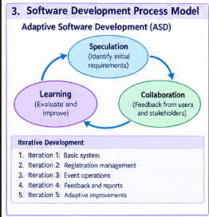
4. Programming Language and Technologies
Component | Technology
Frontend | HTML, CSS, JavaScript
Frontend Framework | React.js
Backend | Java
Backend Framework | Spring Boot
Database | MySQL
API | REST API
Authentication | JWT
Version Control | Git and GitHub
Development Environment | Visual Studio Code / IntelliJ IDEA
Testing | JUnit
Deployment | AWS / Render / Railway
Why these technologies?
React.js provides a dynamic user interface.
Java and Spring Boot can be used to develop secure and structured backend services.
MySQL stores users, events, registrations, attendance, and feedback.
REST APIs allow communication between the frontend and backend.
Git/GitHub helps developers collaborate and maintain different versions of the software.

5. Implementation Strategy
The implementation is divided into multiple iterations.
Iteration 1 – Basic System
Develop:
- User registration
- Login
- Student dashboard
- Event listing
- Event creation
- MySQL database
Iteration 2 – Registration Management
Add:
- Event registration
- Registration cancellation
- Event capacity
- Participant list
- Registration status
Iteration 3 – Event Operations
Add:
- Attendance management
- Event schedule
- Venue information
- Notifications
Iteration 4 – Feedback and Reports
Add:
- Feedback forms
- Ratings
- Event participation reports
- Organizer dashboard
Iteration 5 – Adaptive Improvements
Based on user feedback, additional features can be introduced.
Possible improvements:
- QR-code attendance
- Digital certificates
- Email notifications
- Event recommendations
- Mobile-friendly interface

Basic System Architecture
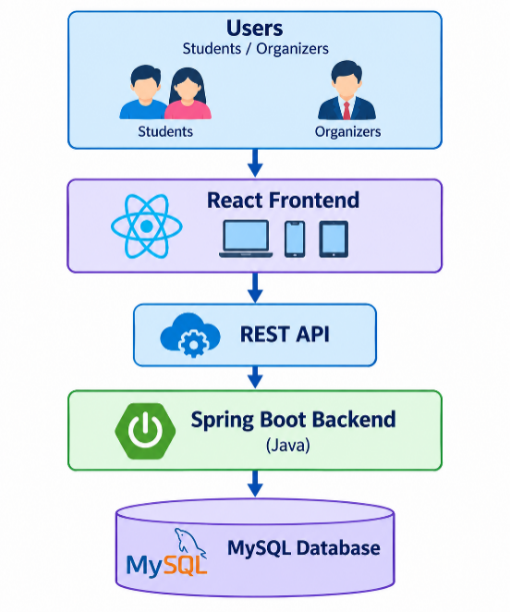

6. Evaluation Strategy
The system will be evaluated from different perspectives.
6.1 Functional Testing
Check whether each feature performs its intended function.
Examples:
- User can register successfully.
- User can log in.
- Organizer can create an event.
- Student can register for an event.
- Registration capacity is correctly maintained.
- Attendance is recorded correctly.
6.2 Usability Testing
Students and organizers can test the application and provide feedback regarding:
- Ease of navigation
- Registration process
- Dashboard design
- Event discovery
- Overall user experience
6.3 Performance Testing
Evaluate:
- Page loading time
- API response time
- Database response
- System behavior with many simultaneous registrations
6.4 Security Testing
Check:
- Authentication
- Authorization
- Password protection
- Unauthorized access
- Input validation
6.5 Adaptive Evaluation
After every development iteration, feedback is collected and requirements are reviewed.
7. UML Diagrams
The assignment requires at least two UML diagrams. You can include these two:
UML Diagram 1 – Use Case Diagram
Actors
- Student
- Event Organizer
- Administrator
Use Cases
Student:
- Register/Login
- View Events
- Register for Event
- Cancel Registration
- View Registration
- Receive Notifications
- Submit Feedback
Event Organizer:
- Login
- Create Event
- Update Event
- Manage Participants
- Record Attendance
- View Feedback
Administrator:
- Manage Users
- Manage Events
- Generate Reports
Use Case Structure
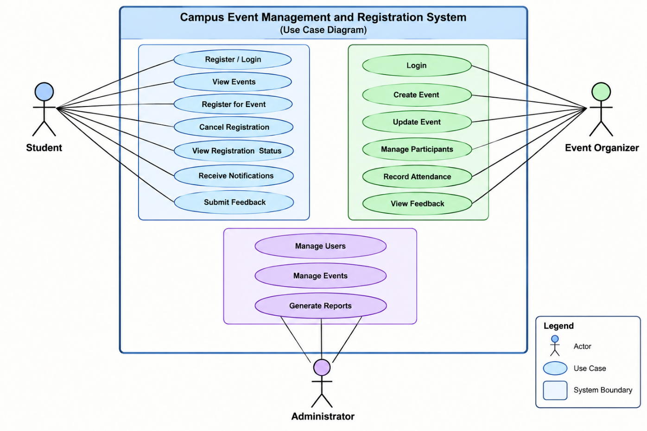

UML Diagram 2 – Activity Diagram
The activity diagram can represent the event registration process
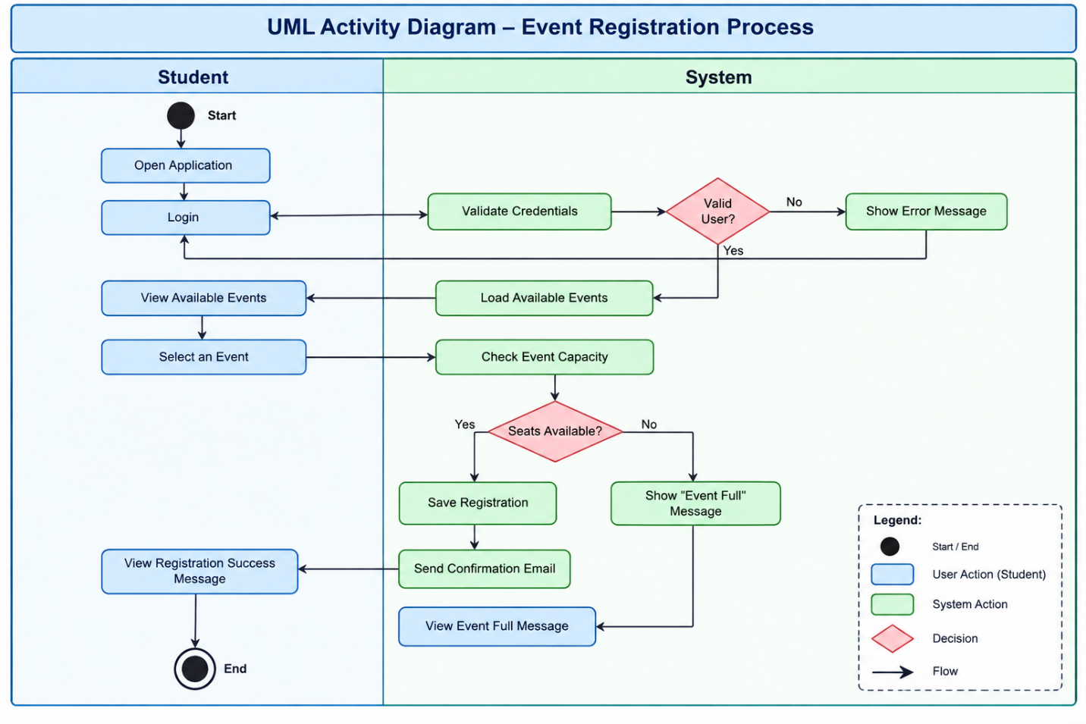

8. Conclusion
The Campus Event Management and Registration System provides a centralized platform for managing college events and participant activities. It reduces manual registration work and provides students, organizers, and administrators with appropriate functionality.
The use of an Adaptive Software Development approach allows the system to evolve according to changing requirements and user feedback. Instead of assuming that all requirements are fixed at the beginning, the system is developed through iterative cycles of development, collaboration, feedback, and improvement.
The proposed technologies such as React.js, Java Spring Boot, MySQL, REST APIs, Git, and JUnit provide a suitable foundation for implementing the application. Future versions can incorporate features such as QR attendance, digital certificates, personalized event recommendations, and mobile support.

